Section F — Editing for Grammar and Spelling  
Each of the underlined words contains either a spelling or grammatical error. Write the  
correct word in each of the boxes. (12 marks)

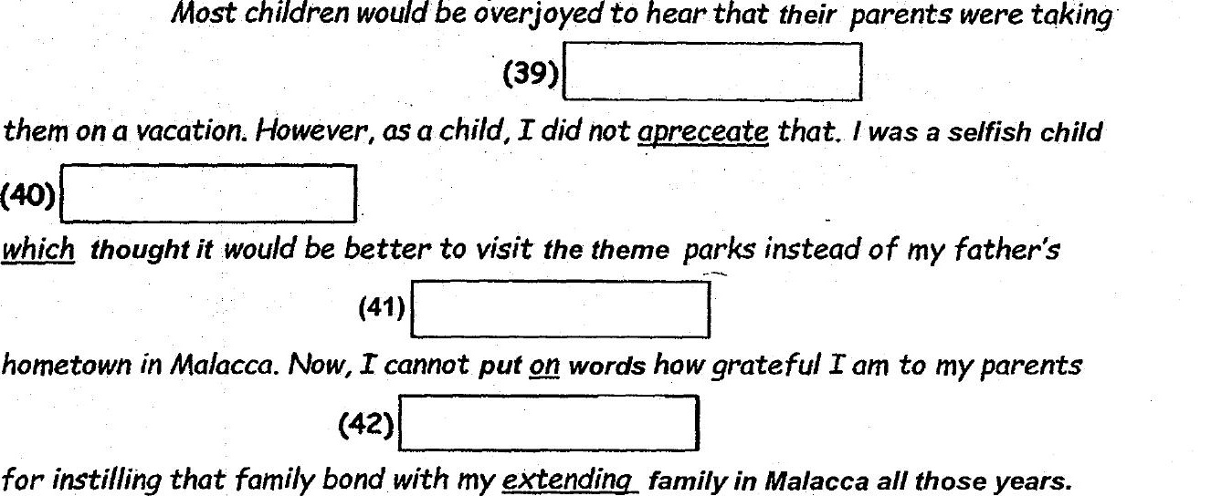

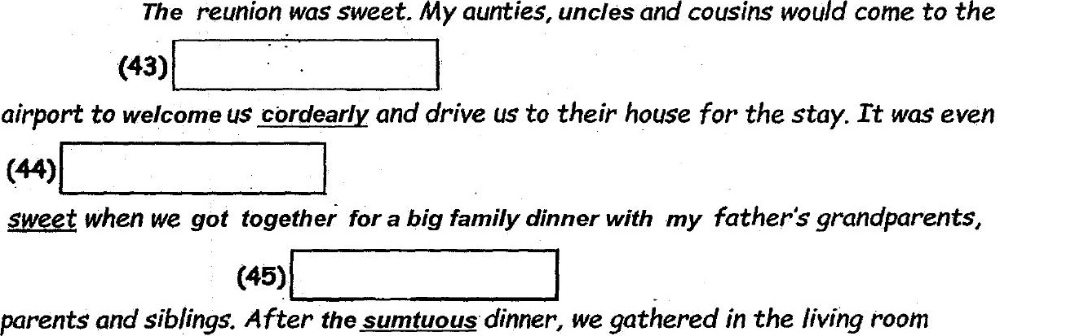

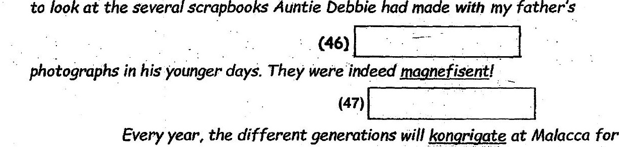

the reunion witnout fail. Watching my children swim and play with my cousins children